Instructions for the US EPA LCMRL Calculator

1 Introduction
This document describes the procedure for calculating an estimated Lowest Concentration Minimum Reporting Level (LCMRL) using R, an open-source and cross-platform programming language designed for statistical computing. The instructions are divided into three sections: downloading and testing the required software, using the LCMRL program to calculate estimated LCMRLs, and the experimental procedure for collecting LCMRL data.
This procedure is intended for use by experienced analysts proficient in the instrumentation associated with the method they are applying it to and the interpretation of its associated data. A valid Initial Demonstration of Capability (IDC) for the applied method must be completed prior to attempting this procedure.

2 Definitions

2.1 R
Formally called The R Project for Statistical Computing, R is a free software environment for statistical computing and graphics.

2.2 Github
Github is public domain, code hosting platform. EPA has selected Github to distribute the LCMRL program.

2.3 Packages
Packages are shared code available from public domain websites such as the R Project website and Github for performing statistical functions in R. To configure R for calculating estimated LCMRLs, the package named LCMRL is required. This package is available as a free download from the EPA page on the Github website. The source code developed by EPA for the LCMRL calculations is embedded in the LCMRL package.

2.4 Dependencies
Dependencies are additional packages that a primary package needs to work properly. These dependencies provide extra functions that the primary package requires but does not include itself.

2.5 Input File for LCMRL Data
The input file is a Microsoft Excel comma separated values (.csv) file containing the results of the laboratory reagent blank (LRB) and laboratory fortified blank (LFB) samples for a partial or completed LCMRL procedure. These data must be arranged in a specific format within the .csv file that is compatible with the LCMRL program (Sect. 4.2).

2.6 Output Files
The LCMRL program generates two output files. First, it writes the LCMRL results to a Microsoft Excel .csv file in tabular format and then afterwards writes the LCMRL graphs in PDF format.

2.7 Source Code
The source code is the programming implementation of the algorithms and routines used for calculating LCMRLs within the LCMRL package.

2.8 Graphical User Interface (GUI)
A GUI is an interactive platform that allows users to engage with the LCMRL package through visual elements like buttons and menus This simplifies the process of data input, parameter customization, and execution of calculations without the need for command-line scripting.

2.9 Working Directory

A Working Directory is a designated folder where the LCMRL package stores input data files, outputs results, and saves configuration settings. This ensures organized and accessible management of all project-related files.

2.10 Test Data
An input file that is used to verify proper download and operation of the LCMRL program. The test data file is embedded in the LCMRL package.

2.11 Laboratory Fortified Blank (LFB)
The LFB is an aliquot of reagent water, containing method preservatives, to which known quantities of the method analytes are added. These are to be processed through the entire method procedure. All method specified steps, such as sample extraction and sample preservation, must be included. The concentration of the analytes in an LFB is called a “spiking level” in the terminology of the LCMRL procedure (Sect. 6).

2.12 Laboratory Reagent Blank (LRB)
The LRB is an aliquot of reagent water containing the method preservatives. These are to be processed through the entire method procedure. All method specified steps, such as sample extraction and sample preservation, must be included. LRBs are used to collect data for the required “zero spiking level” in the LCMRL procedure (Sect. 6).

2.13 Lowest Concentration Minimum Reporting Level (LCMRL)
The single-laboratory LCMRL is the lowest spiking concentration such that the probability of spike recovery in the 50% to 150% range is at least 99%.¹

3 Creating the R Computing Environment for Calculating LCMRLs
The LCMRL calculator runs within the R statistical computing environment. A pre-configured, portable R setup is provided for Windows, Linux and macOS users. This environment includes all the required packages and dependencies including LCMRL. The source code (Sect. 2.7) and test data file (Sect. 2.10) are incorporated into the LCMRL package. Manually building the required computing environment should not be necessary, however general tips for advanced users are provided in Section 10.3 for this task.

3.1 Download the LCMRL Package from Github
Windows users are encouraged to download the most recent preconfigured R environment from the LCMRL Calculator page on Github (https://github.com/USEPA/LCMRL_calculator). Chose or create a folder to save the .zip file to. Upon unzipping, the contents of the folder will be similar to the image below. Section 10.3 provides instructions for a manual installation for macOS and Linux users.
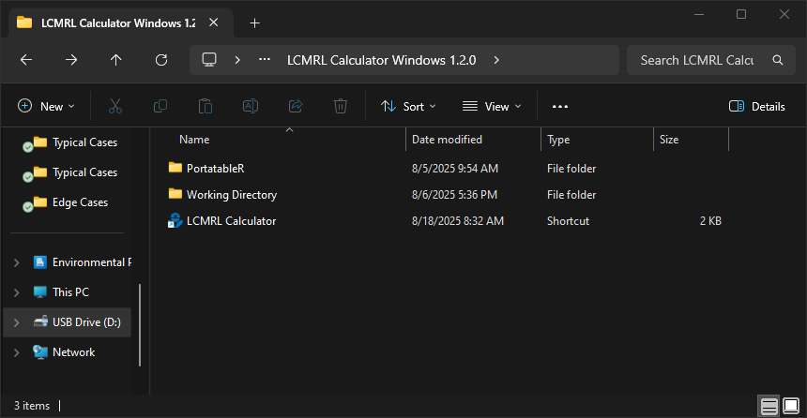

3.2 Launching the LCMRL Calculator
A shortcut to launch the LCMRL Calculator will reside inside the folder created by unzipping the preconfigured R environment. Users can launch the program by double-clicking this shortcut. After a brief loading period, the interface of LCMRL Calculator will appear in the system default web browser as shown below. A cmd window will also open. This window needs to stay open while using the interface. It will close automatically when “Exit” is clicked in the GUI or can be closed manually after closing the GUI.
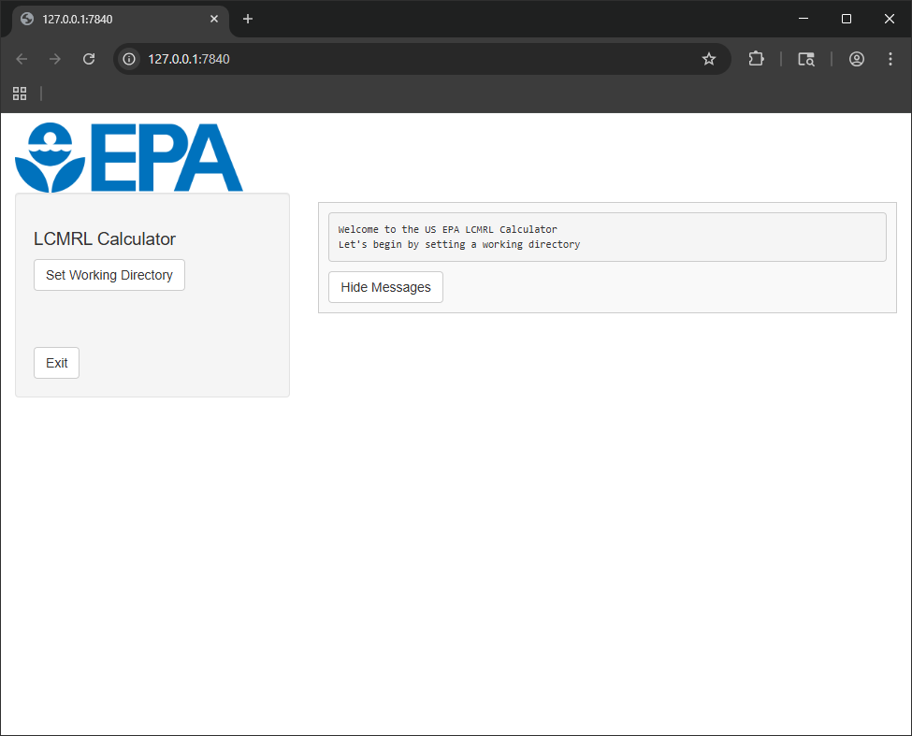

3.3 Setting a Working Directory
Users must first set a working directory before any calculations can be performed. A button labeled “Set Working Directory” is present on the lefthand side of the GUI as shown in the image above. Clicking this button will call the operating system to show a folder selection window. While a folder labeled “Working Directory” is provided with the preconfigured R instance, users are encouraged to set their working directory wherever most convenient for their workflow. The image below shows the GUI after this first step. 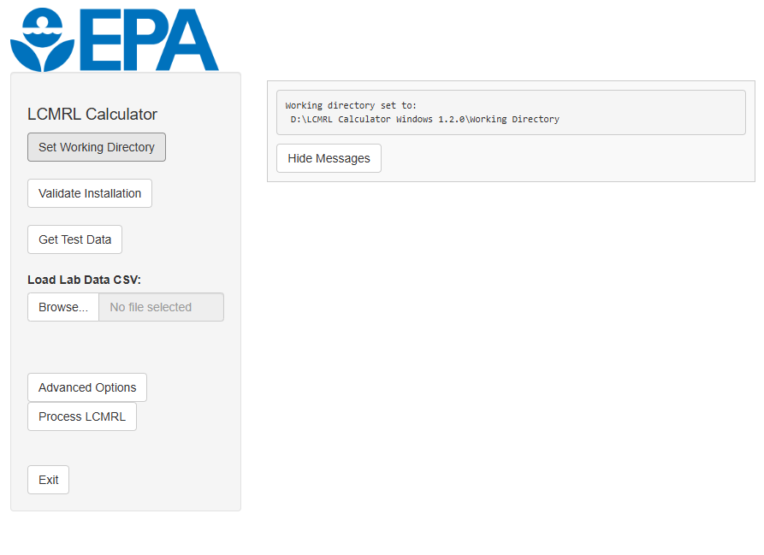

3.4 Validate Installation
Click the “Validate Installation” button on the lefthand side of the LCMRL Calculator GUI. This instructs the program to calculate LCMRLs and their corresponding graphs for five analytes using the test data embedded in the LCMRL package. After processing is complete, the messages panel in the GUI will display “Validation complete” and the working directory will appear in a new window to provide easy access to the output files as shown in the image below.
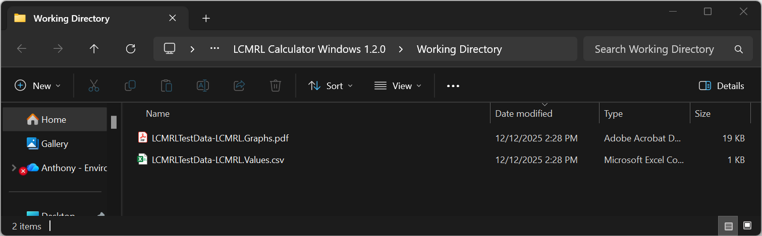
Locate and open the LCMRL output file named LCMRLTestData-LCMRL.Values.csv. Verify that the LCMRLs in Column B and the messages in Column I are identical to those listed in Table 1. Expand Column I to view the full message. Ignore the information in the other columns. Two of the analytes, Analyte 2 and Analyte 4, should give error messages in Column I. These represent the two possible error messages for an incomplete LCMRL determination:
- For Analyte 2, an estimated LCMRL of 1.3 ng/L is reported with the message, “Lower spiking level needed to bracket LCMRL”. See Section 6.1.4 for more information on this circumstance.
- For Analyte 4, the LCMRL is reported as “NA” with the message, “LCMRL is above highest spiking level”. See Section 6.1.5 for more information on this circumstance.
The image below error demonstrates the appearance of this output file in MS Excel.
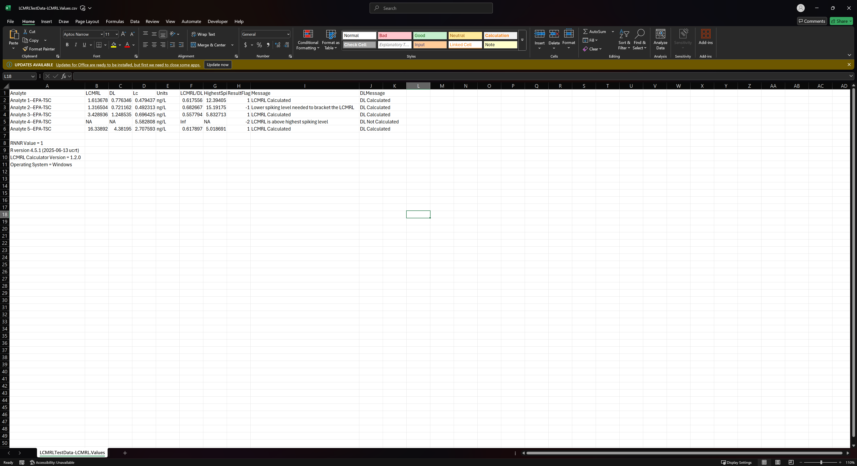
Next, locate and open the LCMRL output file named LCMRLTestData-LCMRL.Graphs.pdf and compare the contents to Figure 5. Two graphs for each analyte should appear: the QC Interval Coverage Plot and the LCMRL Plot. Both graphs for Analyte 2, should display this error message: “LCMRL is Below Lowest Non-Zero SL”. “SL” = spiking level”. For Analyte 4, no graphs will appear in the PDF output due to the “LCMRL is above highest spiking level” error, as observed in Figure 5.

4 Running the LCMRL Program for User Data

4.1 Collect LCMRL Data
Follow the procedure in Section 6 to collect LCMRL data. Arrange the data in a properly formatted input file (Sect. 4.2).

4.2 Creating the Input File for LCMRL Data
The input files are expected to be Microsoft Excel .csv files with a header in the first row. LCMRL results are arranged in rows as illustrated in the image below. The method analytes and concentration levels can be inserted in any order, or you may enter a complete set of LCMRL data for an analyte before proceeding to the next analyte in subsequent rows. Negative values are allowed.
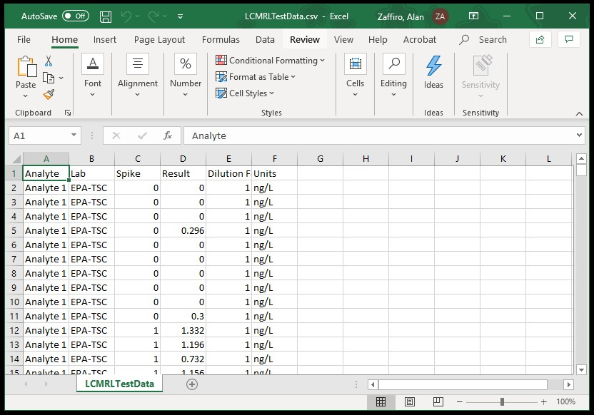
EPA recommends using the test data file embedded in the LCMRL package as a template. To access this file, click the “Get Test Data” button. In the Browse for Folder dialog box, create or select a folder to store the test data. This function will write the test data file to this folder under the name, LCMRLTestData.csv. The image below shows the resulting test data file in an explorer window.
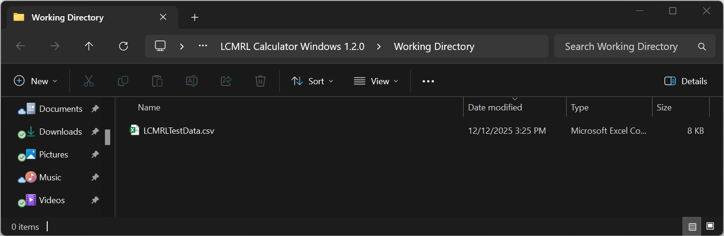
The following rules apply for data entry:
Header, first row, must use the syntax: "Analyte", "Lab", "Spike", "Result", "Dilution Factor", "Units" Column Field Description
- Analyte name (alphanumeric; no commas should appear in the name)
- Lab name (alphanumeric; no commas should appear in the name)
- Spiking level (numeric); enter “0” for laboratory reagent blanks (LRBs)
- Measurement (numeric)
- Dilution factor (numeric). Program at this time only expects dilution factors of 1.
- Units of measurement (alphanumeric with no commas)

4.3 Calculating an Estimated LCMRL Using Default Modeling Parameters
The default modeling parameters are the core of the intended workflow for nearly all use cases of the LCMRL Calculator. First click the “Browse” button to load your input file. This will call the operating system to show a file selection window. Navigate to and select your desired input file. The calculator will then perform data quality checks and indicate the results in the messages pane on the righthand side of the GUI. When no issues are detected, a green check mark will be displayed as shown in the image below. In cases issues are present, a red X will be displayed along with a warning message about the specific error. Please see Section 6 for more detailed information on data requirements for the calculator.
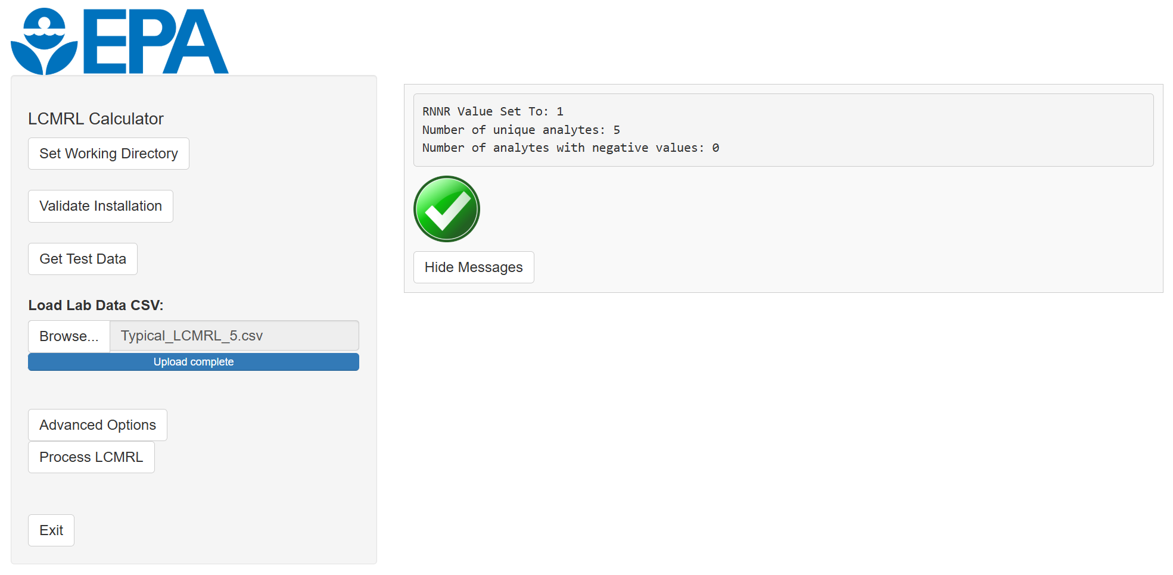
After the data set is loaded and has passed the initial quality checks, click the "Process LCMRL" button. This prompts the program to calculate the LCMRLs and generate corresponding graphs for the analytes in the data set. Upon completion, the messages panel in the GUI will display "Processing complete," and a new window will open, providing easy access to the output files in the working directory.

4.4 Errors
For data formatting type errors, the LCMRL program will cease processing upon reaching that point in the data set for one of the analytes. In most cases these errors are triggered by an incorrect entry or unallowed syntax in the input file. Effective troubleshooting involves verifying that the input file is correctly formatted as described in Section 4.2. For issues with data quality or otherwise compromised LCMRL estimations please see Section 10.2.1.

4.5 LCMRL Values Output File
If no formatting issues are present, the LCMRL program writes a new .csv file to the working directory. The analytes and their LCMRL values are listed in the order they were entered into the input file. When processing is complete for all analytes, the working directory will appear.
The calculator uses the name of the input file appended by “–LCMRL.Values.” to name the output file. If the name of the user input file is “Method 558.csv”, the resulting output file name would be “Method 558–LCMRL.Values.csv”.
Comma separated values (.csv) files are not formatted and the user must expand the columns to view the full text of the analyte names and the messages in Column I. To retain formatting, save the .csv file as a Microsoft Excel Workbook (.xlsx).

4.6 LCMRL Graphs Output File
The program writes a PDF to the working directory with two plots for each analyte. After processing is complete, the working directory will appear.
The calculator uses the name of the input file appended with “–LCMRL.Graphs” to name the output file. If the name of the user input file is “Method 558.csv”, the generated PDF would be named “Method 558–LCMRL.Graphs.pdf”. See Section 6.9 for a description of the information contained in these plots.

5 Advanced LCMRL Functions
The LCMRL estimation used in these instructions is an abstracted form of the full underlying source code that calls five arguments, sometimes referred to as modeling parameters. Note that the “rnnr” flag for negative LCMRL values is not considered a modeling parameter. Three of the five modeling parameters define constraints used in the calculation of the LCMRL: LQL, UQL, and CPR. Two define constraints for the calculation of a detection limit based on the theory advanced by Hubaux and Vos (1970): alpha and beta.²

5.1 Changing the LCMRL Modeling Parameters
The LCMRL calculator has the capability to estimate LCMRLs using different lower quality limits (LQL), upper quality limits (UQL), and coverage probabilities (CPR) than the default values. This capability has been retained for users who wish to generate LCMRLs consistent with their own data quality objectives and programmatic goals. These parameters can be set manually by clicking the “Advanced Options” button. The LCMRL modeling parameters and the steps for running scripts with alternate modeling parameters are described in the Section 10.1. 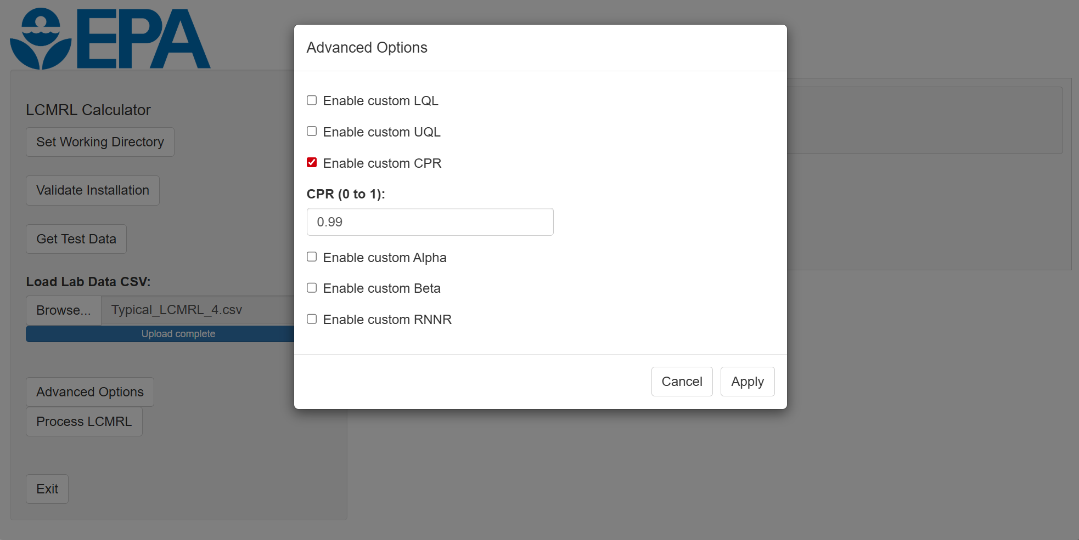

5.2 Modified Hubaux-Vos Detection Limit
The modified Hubaux-Vos Detection Limit (mHV-DL) is defined by EPA as the spiking concentration that has a 95% probability of exceeding the 95% critical level.¹ The conditional distributional model constructed for determining the LCMRL is also used to determine the mHV-DL. The LCMRL calculator generates an mHV-DL for each method analyte and writes it to the same .csv file containing the LCMRL results. The modeling parameters may be altered for the calculation of the mHV-DL as described in the Section 10.1. The calculated mHV-DLs for the five analytes in the test data included with the LCMRL package are given in Table 1.

6 Procedure for Collecting LCMRL Data
The LCMRL Procedure requires a minimum of four LFBs at each of seven concentrations, or “spiking levels”. These LFBs, plus a minimum of four LRBs, or “zero spiking level”, are processed through the entire method procedure. All method specified steps, such as sample extraction and sample preservation, must be included.
The following subsections provide detailed instruction for conducting the LCMRL study. An overview is provided here.
Calibrate the analytical instrument. Suggested calibration ranges for the method analytes and concentrations for the internal standards and surrogates can be found in the EPA method.
Start by selecting five spiking levels that will be used to estimate the LCMRL for each analyte. Section 6.1 including subsections discuss criteria useful for determining appropriate concentrations. Make sure each LFB concentration you select is bracketed by calibration standards (Sect. 6.2.2). After you complete five of the seven LFB levels, calculate LCMRLs for the method analytes.
Select at least two more LFB levels. See Section 6.1.2 for guidelines on appropriate LFB concentrations. As you complete these additional levels, update the LCMRL input file with the additional data and calculate revised LCMRLs. For each analyte, the LCMRL program will display a message in the output file indicating whether a valid LCMRL has been determined or if additional spiking levels are required. Follow the recommendations in Section 6.1.4 (lower level LFB needed) and Section 6.1.5 (higher level LFB needed) to add additional spiking levels until valid LCMRLs are determined for each analyte.

6.1 LFB Concentrations and Considerations

6.1.1 Concentrations Must Bracket LCMRL
Proper LCMRL calculation requires that at least one LFB concentration level be at, or below, the LCMRL and at least one LFB level be at, or above, the LCMRL. If an LCMRL is determined without this requirement, then at least one more level of LFBs must be processed to include the LCMRL within the concentration range of the LFBs.

6.1.2 Range of LFB Concentrations
The range of LFB concentrations are to span from slightly below the LCRML to no more than a factor of twenty above it. To achieve this, the LCMRL study should be constructed with the highest LFB concentration set at a value below 20-fold the planned lowest spiking level. Spiking levels that far exceed the LCMRL are detrimental to its estimation and can lead to a biased result. If the analyst is familiar with the analyte response, an estimate for a low-level spiking concentration can be where the mean of replicates is close to the accuracy extremes of 50 and 150% or where reproducibility begins to break down. Otherwise, it is suggested to fortify the lowest LFB set at a concentration that yields a signal-to-noise ratio of about 3 to 5. In cases where interferences are present, one might use a low-level estimate of twice the equivalent concentration of the analyte peak as found in the method blank. The accuracy and precision for data lower than the LCMRL may be of poor quality, but it is necessary to find at what concentration data quality begins to break down. More than seven levels of LFBs may be needed to observe this recommendation for multi-analyte methods.

6.1.3 Counting LFB Levels
For each analyte, three of the four analyses in each spiking level must be reported as non-zero results or that level does not count toward the required seven LFB levels. LRBs do not count as one of the required seven spiking levels.

6.1.4 When LCMRL Estimate is Less than the Lowest LFB Concentration
When the calculated LCMRL is lower than the lowest LFB spiking level, an estimated LCMRL result will appear in the output file with a message: “Lower spiking level needed to bracket the LCMRL.” This means that the LCMRL program needs a lower LFB level to calculate a valid LCMRL. Fortify this additional LFB below the estimated LCMRL while retaining as much signal to noise as possible. Practically speaking, at least one spiking level must fail LCMRL QC limits to determine an LCMRL.
If the lower spiking level is below the current calibration range, a calibration standard must be added at, or below, the concentration of the added LFB. Run a new calibration with the additional standard included. The new low-level calibration standard may fail the method QC limits for calibration, but this calibration level should be allowed so that the LCMRL calculator can determine an LCMRL. Completed LFB levels do not have to be re-analyzed.

6.1.5 When LCMRL Estimate is Greater than the Highest LFB Concentration
When the calculator determines that an LCMRL estimate is higher than the highest LFB spiking level, a default value of “NA” will appear in the output file. Additionally, this message will appear: “LCMRL is above highest spiking level”. This means that when the calculator processed the LFB results, the LCMRL QC probability limits were greater than 50 to 150%, even at the highest level. If an LCMRL is to be determined, a higher LFB level must be processed. This assumes that accuracy and precision will improve at higher spiking levels. For example, if the method cannot extract at least a recovery of 50% at any concentration, an LCMRL defined as “between 50 and 150% recovery” cannot be determined. At least one spiking level needs to pass LCMRL QC probability limits to determine an acceptable LCMRL.
If the higher spiking level exceeds the current calibration range, a calibration standard must be added at, or above, the concentration of the added LFB. Run a new calibration with the additional standard included. Completed LFB levels do not have to be re-analyzed.

6.1.6 Running Out of Response
If the calculated LCMRL is below the lowest LFB concentration and lower spiking levels do not produce an integrable signal, then the laboratory should set the LCMRL at the lowest useable LFB concentration.

6.2 LCMRL Calibration Range

6.2.1 Use a Typical Range
The concentration of the highest calibration standard should be consistent with routine analysis. The instrument calibration range should be typical of expected routine sample analysis. The use of an instrument calibration that has an unreasonably narrow range may yield a lower LCMRL, but the LCMRL will not reliably reflect performance during routine analysis. The calibration range must not exceed the response that begins to saturate the detector. Note, due to the iterative nature of this process, it may be necessary to add additional points to the low end of the calibration.

6.2.2 Range Must Encompass LFB Spiking Levels
The concentration of the LFBs must lie within the range of the calibration. Spiking levels are invalid if their concentration exceeds the calibration range at the low or high end.
6.3 Include Laboratory Reagent Blanks in Data Set
At least four LRBs must be included in the dataset. If the LRB does not have a response, report “0”.

6.4 Estimate LCMRL after Five Spiking Levels
It is recommended to calculate the LCMRL after the first five spiking levels have been processed so that the next two LFB concentrations can be selected based on the estimated LCMRL. A lower or higher concentration may be needed to ensure the LCMRL is bracketed by LFBs. If the estimated LCMRL is already bracketed, select additional concentrations within the existing range, or expand the range at either end keeping the LFB concentrations as close as possible to the estimated LCMRL.

6.5 Outliers
Extreme data observations, or outliers, can occur. An outlier may represent the actual lack of reproducibility of the method at that concentration. An outlier may also result from changed conditions that represent a different population of data. Additionally, an outlier may be due to analyst error. If the reason for an outlier is known, such as a double spike, that data should not be used. Otherwise, the data should be used.

6.6 Formatting Conventions for Data

6.6.1 Numerical Results
At least three significant figures for each non-zero result should be reported for LFB and LRB samples and entered into the LCMRL input file. Otherwise, the variance may be artificially reduced, resulting in an artificially low LCMRL. Because data systems may truncate the number of digits at the low end of the calibration curve, this requirement may need to be addressed by selecting a lower set of units for the LCMRL analyses. Note that numerical results ending in zero are truncated in .csv files. For example, a result of 4.00 ng/L would appear in the .csv input file truncated as “4”. This is normal and does not affect the calculation. To avoid rounding issues, units for these values should be adjusted to produce numbers no greater than 1,000 and no less than 1.0 X 10⁻⁶.

6.6.2 Report No Response as Zero
Instrument software may not report a result when there is not a peak to integrate. Report such an analysis as “0”. In addition, when a software system reports “below calibration,” enter “0”.

6.6.3 Negative Values
At low-level concentration, some instrument software systems will report negative numbers. Enter negative values into the input file and calculate LCMRLs as you would normally.

6.7 No Time Requirement
The LCMRL procedure does not have a time requirement for LFBs to be processed and analyzed. The LFBs can be processed all at once or over time.

6.8 Confidence Level and Data Quality Interval
A reporting level is defined in terms of level of confidence and data quality. The 99% confidence level that is used for the prediction interval is considered conservative, but for drinking water surveys the quality of the data is important. The data quality interval that was chosen for the LCMRL, 50 to 150%, was based upon the judgment of experienced analysts at OGWDW.

6.9 Interpreting the LCMRL Graphs
The LCMRL calculator produces two graphs, or plots: the QC Interval Coverage Plot and the LCMRL Plot.
See Figure 5 for examples. The QC Interval Coverage Plot is based directly on the definition of the LCMRL. It shows the coverage probability by measured values for the interval defined by 50-150% recovery as a function of spiking level. The x-coordinate of the point at which the curve crosses the line at y=0.99 is the LCMRL. The LCMRL Plot contains the following information, which gives a more intuitive picture of the measurement process and the LCMRL.
- Plot of measured concentration (y-axis) vs. spiking concentration (x-axis)
- Weighted least squares regression curve
- A 99% prediction interval (PI) about the regression
- Plot lines that correspond to 50% and 150% recovery
- A symbol (cross) that indicates where the LCMRL falls on the line y = x

7 References
- US EPA. Technical Basis for the Lowest Concentration Minimum Reporting Level (LCMRL) Calculator; EPA 815-R-11-001; Office of Water: Cincinnati, OH, December 2010.
- Hubaux, A. and G. Vos. Decision and Detection Limits for Linear Calibration Curves. Analytical
Chemistry 1970, Vol. 42, No. 8, pp. 849-855.

8 Tables
LCMRL Results for the Test Data, ng/L
Analyte | LFB Spiking Levels | LCMRL | mHV-DL | Message
Analyte 1--EPA-TSC | 1.0, 2.0, 4.0, 6.0,  10, 14, 20 | 1.6 | 0.78 | LCMRL Calculated
Analyte 2--EPA-TSC | 2.0, 4.0, 6.0, 10,  14, 20 | 1.3 | 0.72 | Lower spiking level needed to bracket the LCMRL
Analyte 3--EPA-TSC | 1.0, 2.0, 4.0, 6.0,  10, 14, 20 | 3.4 | 1.2 | LCMRL Calculated
Analyte 4--EPA-TSC | 1.0, 2.0, 4.0, 6.0,  10 | NA | NA | LCMRL is above highest spiking level
Analyte 5--EPA-TSC | 4.0, 6.0, 10, 14, 20,  41, 82 | 16 | 4.4 | LCMRL Calculated

9 Figures
Correct Appearance of the LCMRL Graphs for the Test Data
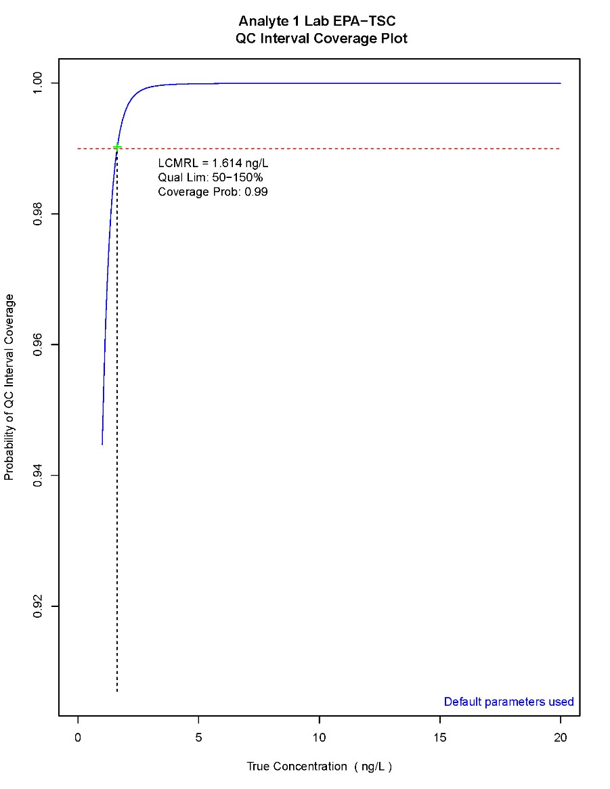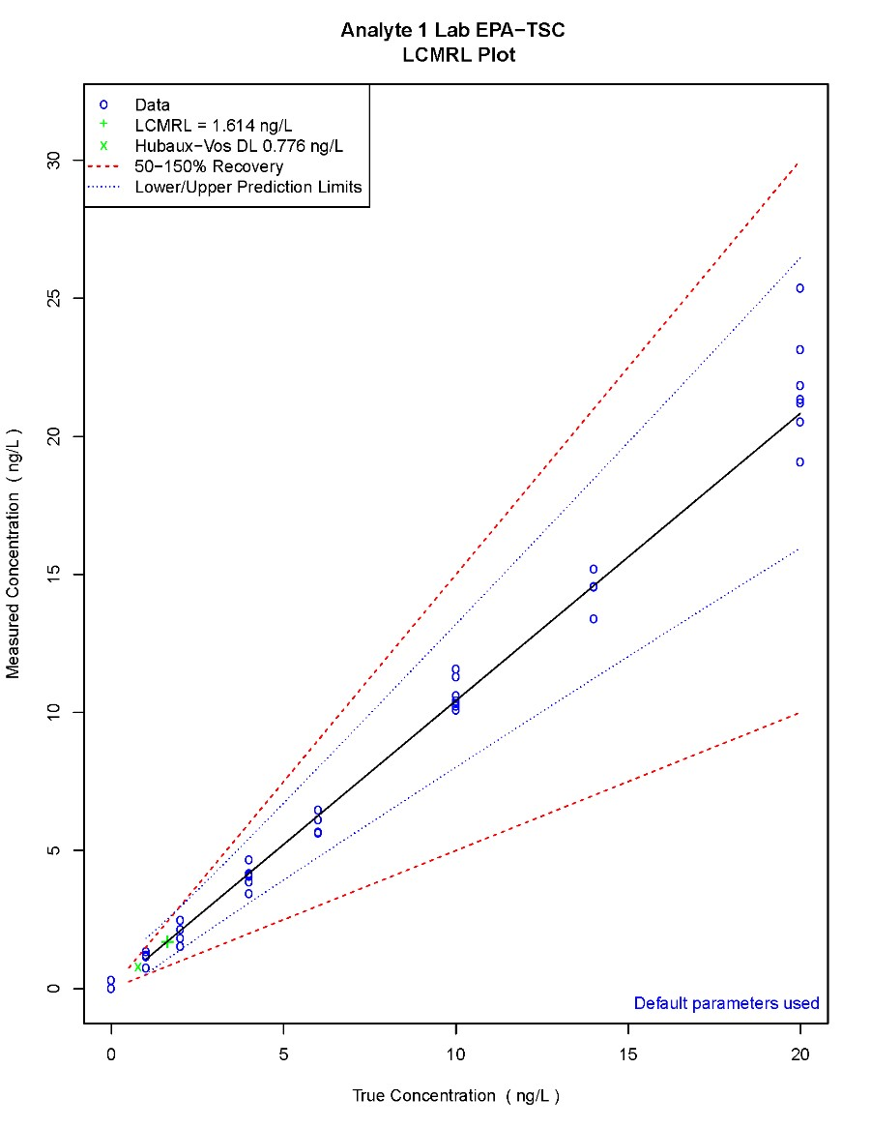

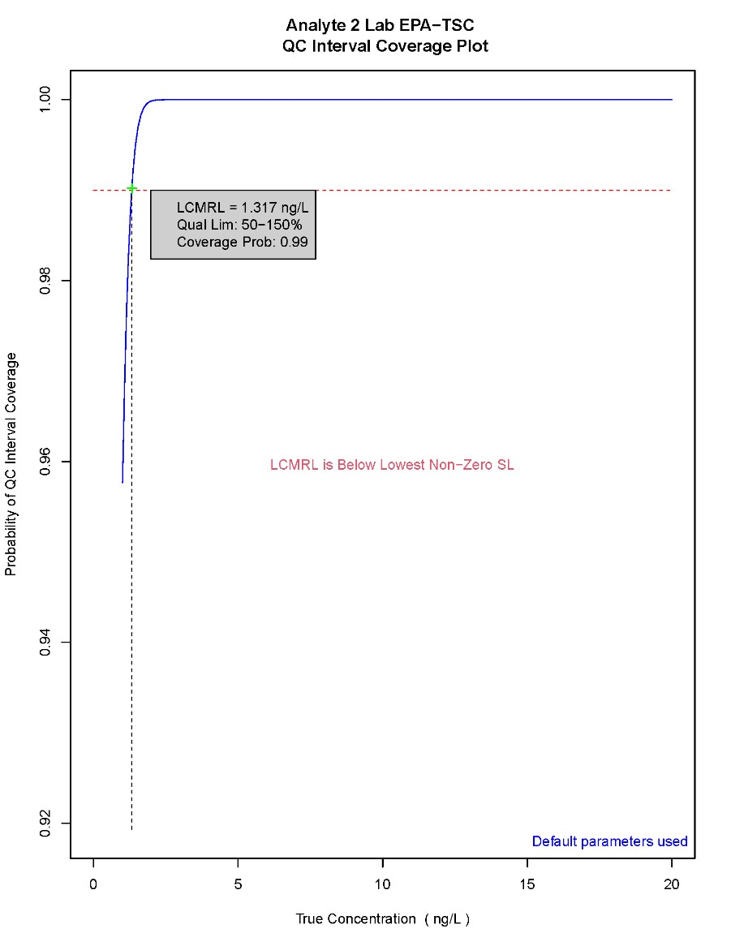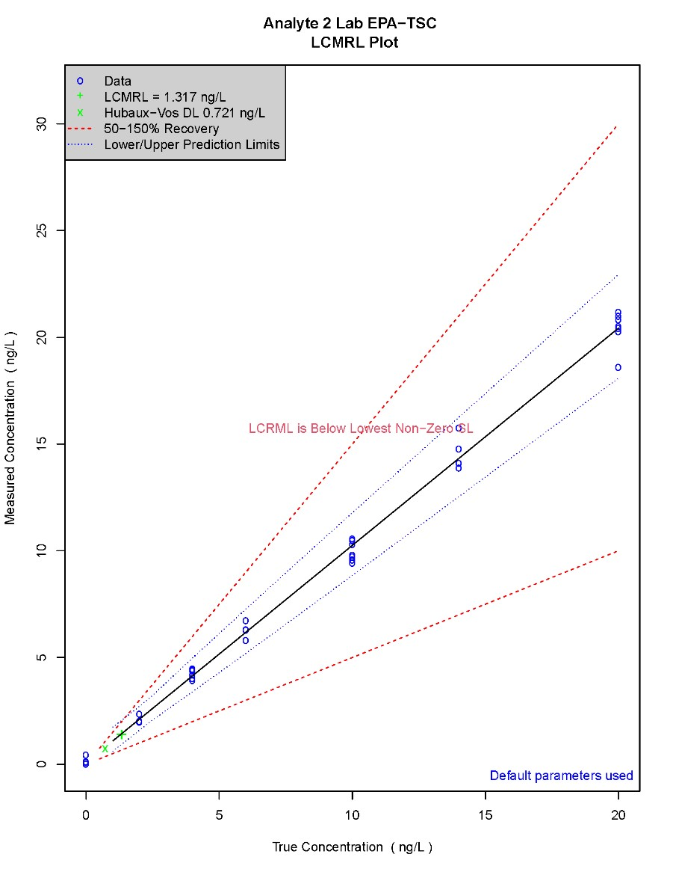

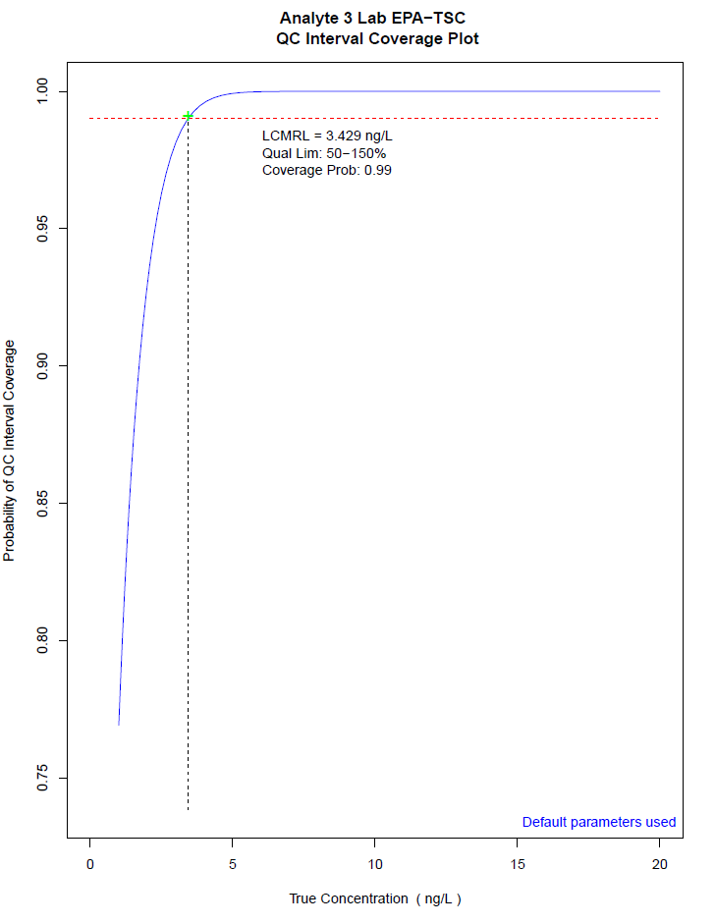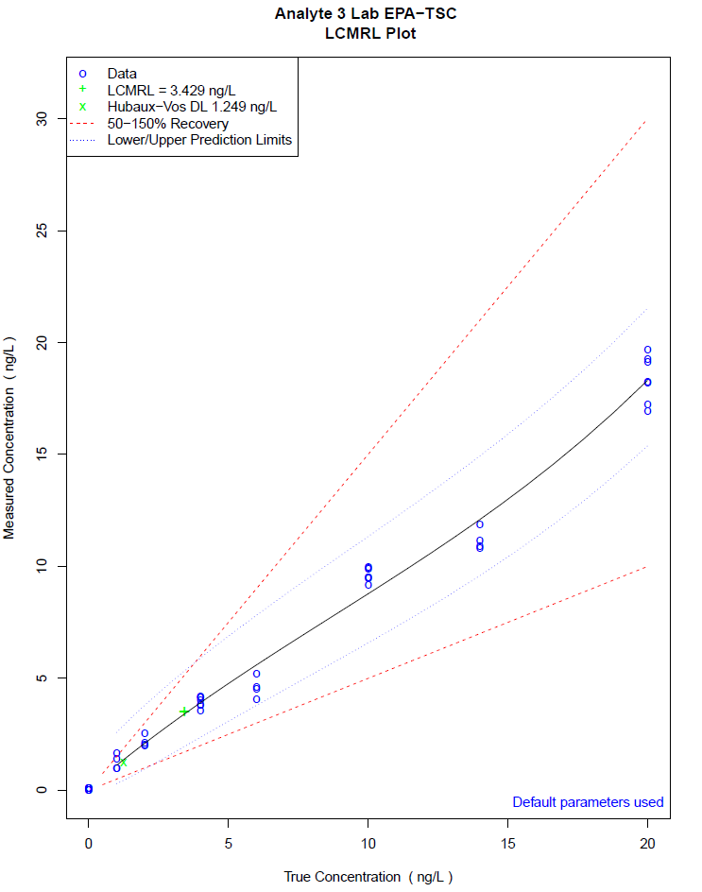

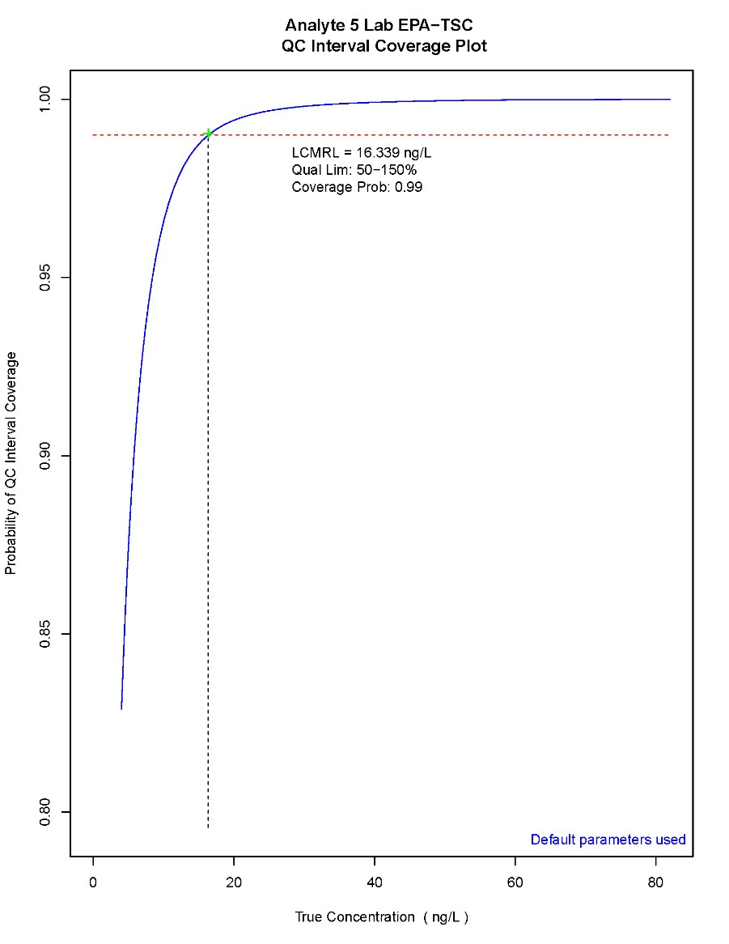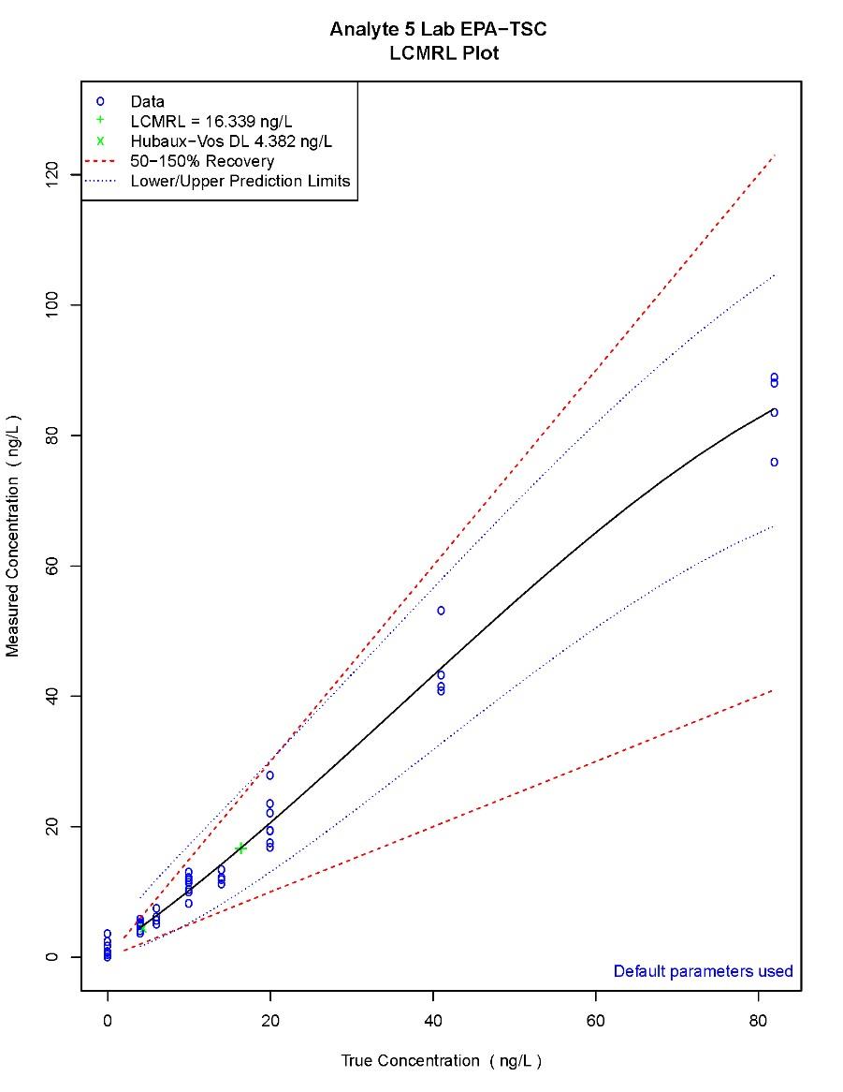

10 Appendix

10.1 Alternate Modeling Parameters
The procedure for collecting LCMRL data (Sect. 6) and formatting the input file (Sect. 4.2) are identical to the procedure using the default parameters. Users should consult the technical basis document¹ available on EPA’s LCMRL webpage to gain an understanding of the statistical significance of the modeling parameters.

10.1.1 Modeling Parameters, Default Values, and Input Ranges
LQL Lower Quality Limit default is 0.5. Can be reset to a value between 0 and 1.
UQL Upper Quality Limit default is 1.5. Can be reset to a value between 1 and 2.
CPR Coverage Probability default is 0.99. Can be reset to a value between 0 and 1.
Alpha Alpha value for the mHV-DL with a default of 0.05. Can be reset to a value between 0 and 1.
Beta Beta value for the mHV-DL with a default of 0.05. Can be reset to a value between 0 and 1.
RNNR Required Non-Negative Response flag. The default for the rnnr flag is 1.
The intended use of the rnnr flag is to use 1 for LCMRL data with only positive values and 0 if the data set includes negative values. When using default settings, this flag is set automatically. The Alpha and Beta values apply only to the calculation of the modified Hubaux-Vos detection limit (mHV-DL).

10.2 Troubleshooting
This section is designed to give user basic assistance with the most common issues experienced when using the LCMRL Calculator.

10.2.1 Data Quality Warnings
Version 1.2.0 of the LCMRL Calculator introduced basic, automated data quality checks. The 3 primary triggers for these warnings include mixed positive and negative data sets, inappropriate units, and highest spike concentrations greater than 20-fold the calculated LCMRL. The image below shows the red X displayed by the GUI when a warning is triggered.
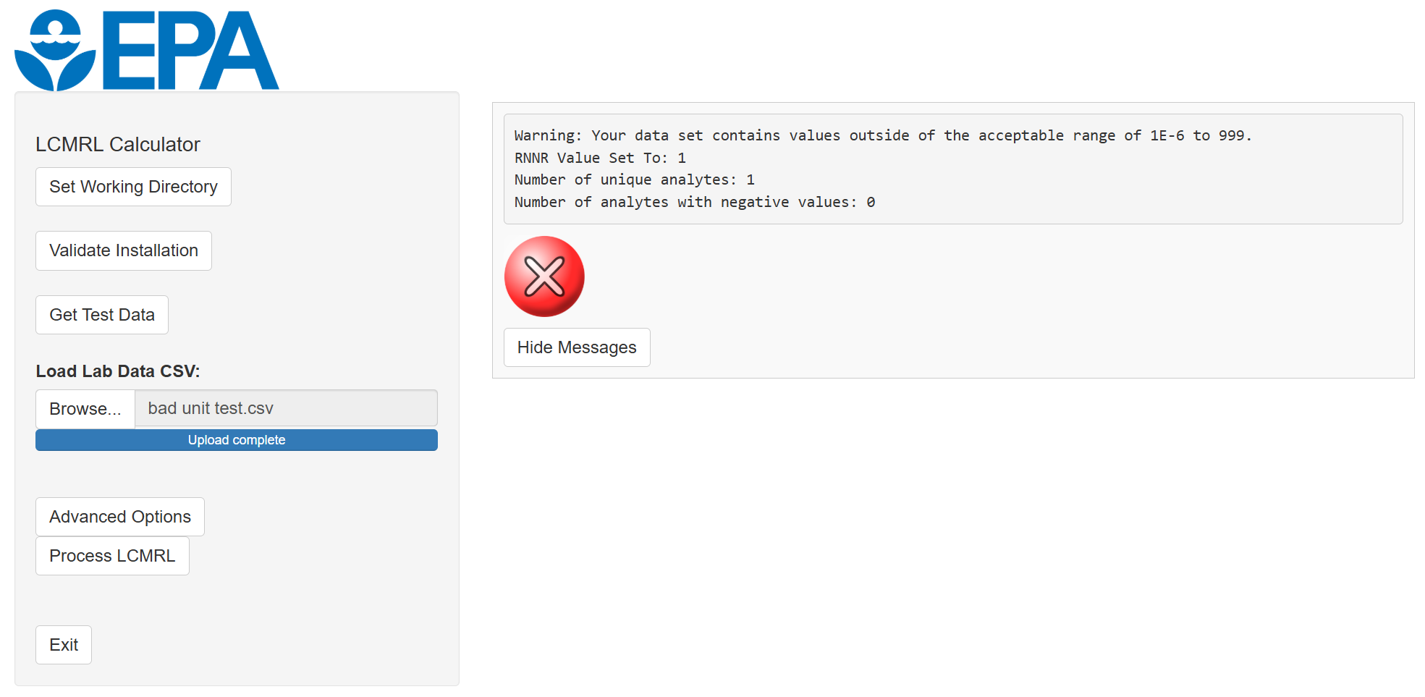
These issues have straightforward solutions in most cases. For example, the mixed positive-negative data sets can be resolved by splitting the input file into two separate .csv files, one containing the analyte(s) with negative reported values, and the other with the positive only analytes. This resolves potential issues with the rnnr flag.
The inappropriate units warning is triggered when results contain values greater than 1,000 or less than 1E-6. This can be resolved by converting to a more suitable unit, such as converting from ng/L to µg/L or mg/L when dealing a very small number or in the other direction for very large ones.
The 20 fold ratio warning is typically the most involved as in most cases when it is triggered, the laboratory will not have 7 valid spiking levels under the 20-fold threshold. Ultimately, these situations require additional spiking levels to be analyzed to meet the program requirements.

10.2.2 Session Timeout
Due to inherent issues with the R programming language, an inactivity timeout routine was implemented to avoid a “soft-lock” situation where the GUI would become unresponsive with no obvious solution available to the user. This timer only applies to the welcome screen of the program and is disabled once users set a working directory. The figure below demonstrates the behavior of the session timeout routine.
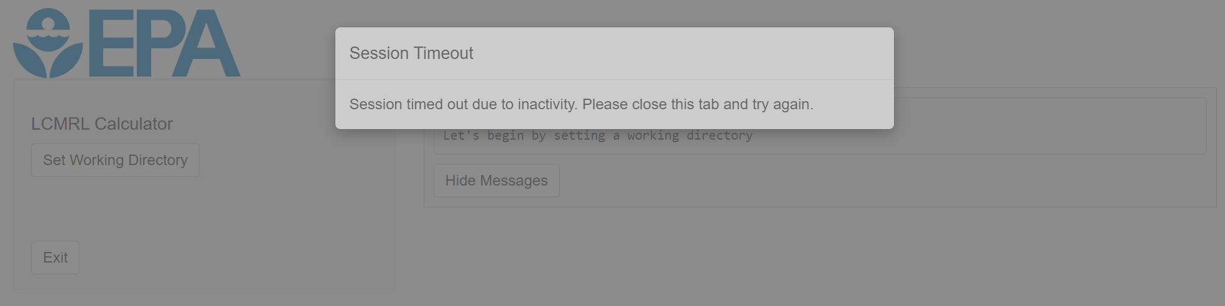

10.2.3 Miscellaneous Errors
The LCMRL Calculator relies on several external dependencies, which are maintained independently from this project. As these dependencies are subject to updates and changes, it is not feasible to provide a comprehensive list of potential error messages. Users should be aware that error messages may vary and evolve over time. However, the source of these miscellaneous errors is largely predictable. The image below represents the format of a miscellaneous error as of the release of version 1.2.0 of the LCMRL Calculator.
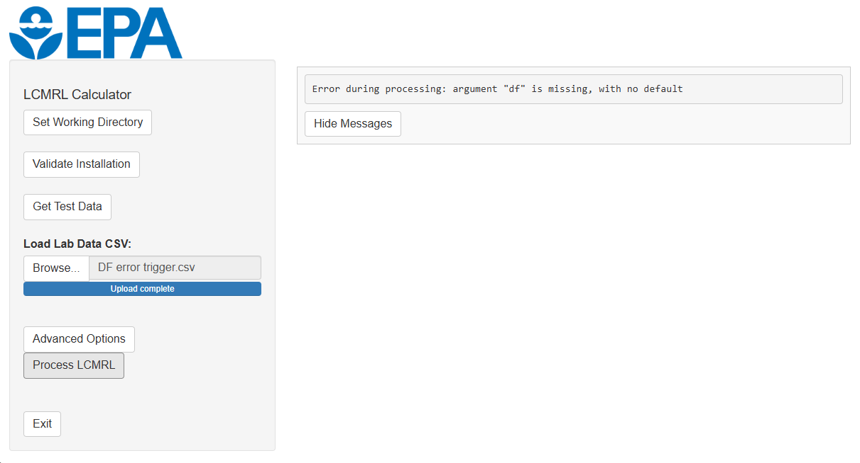
Regardless of the exact phrasing of the error, issues of this nature are most effectively diagnosed by assessing the input file. If the dataset contains multiple analytes and/or multiple labs, breaking the input file down into smaller sets, such as to a single lab or analyte, can typically identify the issue. The nature of these issues is generally related to data quality requirements that only become noticeable during processing. For example, prior to calculation a dataset may have adequate numbers of spiking levels and replicates, but if multiple replicates are rejected as outliers across enough spiking levels the dataset can be invalidated during the calculation process. This is most easily resolved by removing the suspect spiking level from the dataset and reprocessing. Situations like this example may require additional data collection in the form of replicates or spiking levels in order to reach a point where a valid LCMRL value can be calculated.

10.3 Manually Building Compatible R Environments
While the provided assets on GitHub include a preconfigured portable R instance for Windows, some users may require a manual installation. Such cases include those running macOS or Linux and those who prefer to add LCMRL Calculator functionality to a current installation of R.

10.3.1 R Download
Go to https://cloud.r-project.org/. This link will take you to a webpage titled The Comprehensive R Archive Network (CRAN). Follow the links to download the most recent version of R appropriate for your operating system. Install the R software following the steps for your operating system.

10.3.2 Installing Required Packages
Open R and enter the following command at the R console:
install.packages(c("car", "doParallel", "foreach", "iterators", "lattice", "parallel", "rstudioapi", "shiny"))
This will instruct R to download and install the required dependencies from CRAN. Next download the source version (filename ending with .tar.gz) of the LCMRL package from GitHub and save it to a known location. Now run the following command replacing “/home/user/Downloads/LCMRL_1.2.0.tar.gz” with your file path and filename:
install.packages("/home/user/Downloads/LCMRL_1.2.0.tar.gz", repos = NULL, type = "source")

10.3.3 Launching the LCMRL Calculator
Open R and enter the following command at the R console:
library(LCMRL); run_LCMRL_GUI()
This will instruct R to load the required dependencies and launch the LCMRL Calculator.

. LFB = Laboratory Fortified Blank
. mHV-DL = Modified Hubaux-Vos Detection Limit

